Implementation of Irrigation Modernization Management in Jiamakou Yellow River Diversion Project, Shanxi Province, China
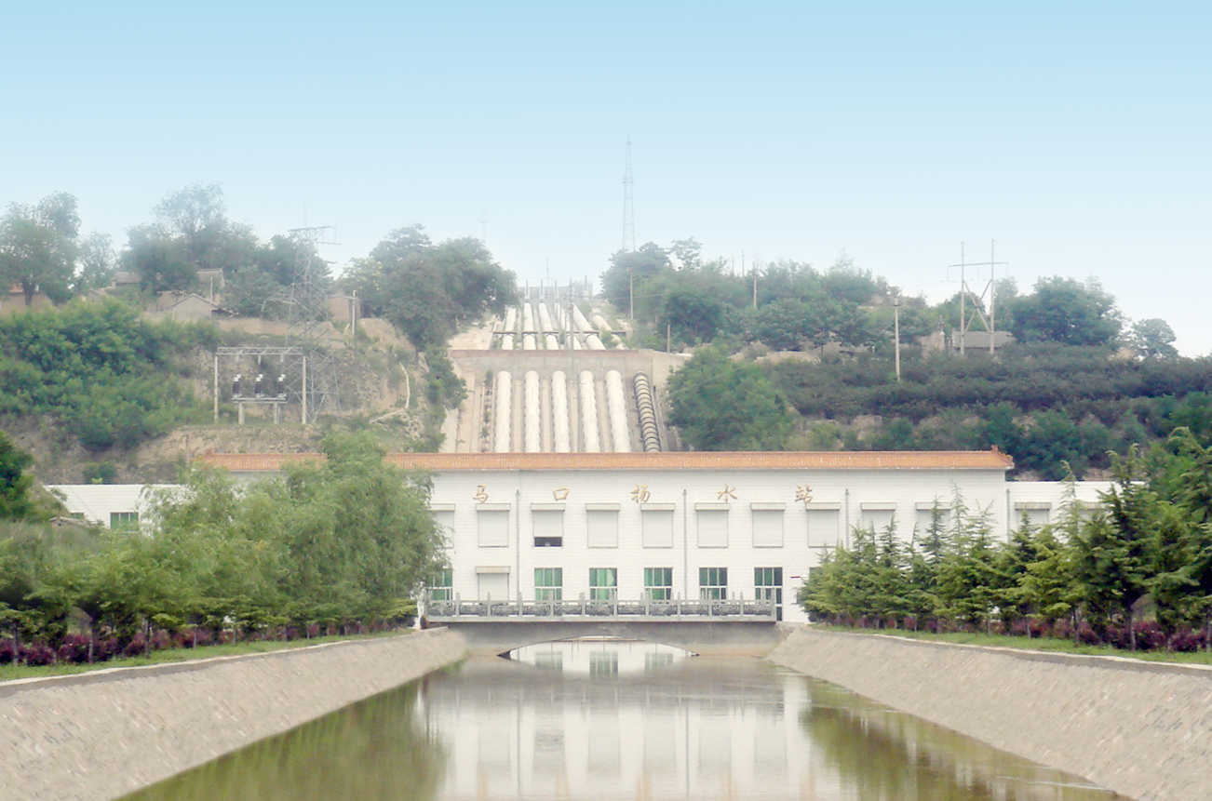

Zhang Xuehui

Jiamakou Yellow River Diversion Administration Bureau
Yuncheng City, Shanxi Province, China

Contents

I Introduction
II Understanding to modernization management of irrigation system
III Basic elements of modernization management of irrigation system
VI Benchmarking management
V Initial modernization achievements
VI Major problems
VII Conclusions

I INTRODUCTION

Jiamakou Yellow River Diversion Project (JYRDP) is located in Yuncheng City, southwest of Shanxi Province and the middle reach of the Yellow River. The weather in Yuncheng City is characterized by a warm continental monsoon climate and semi-aridity region. The annual temperature is between 11.8 to 13.7℃ with a frostless period of 186~235 days. Annual precipitation ranges from 490 to 620mm and is unevenly distributed both temporally and spatially.
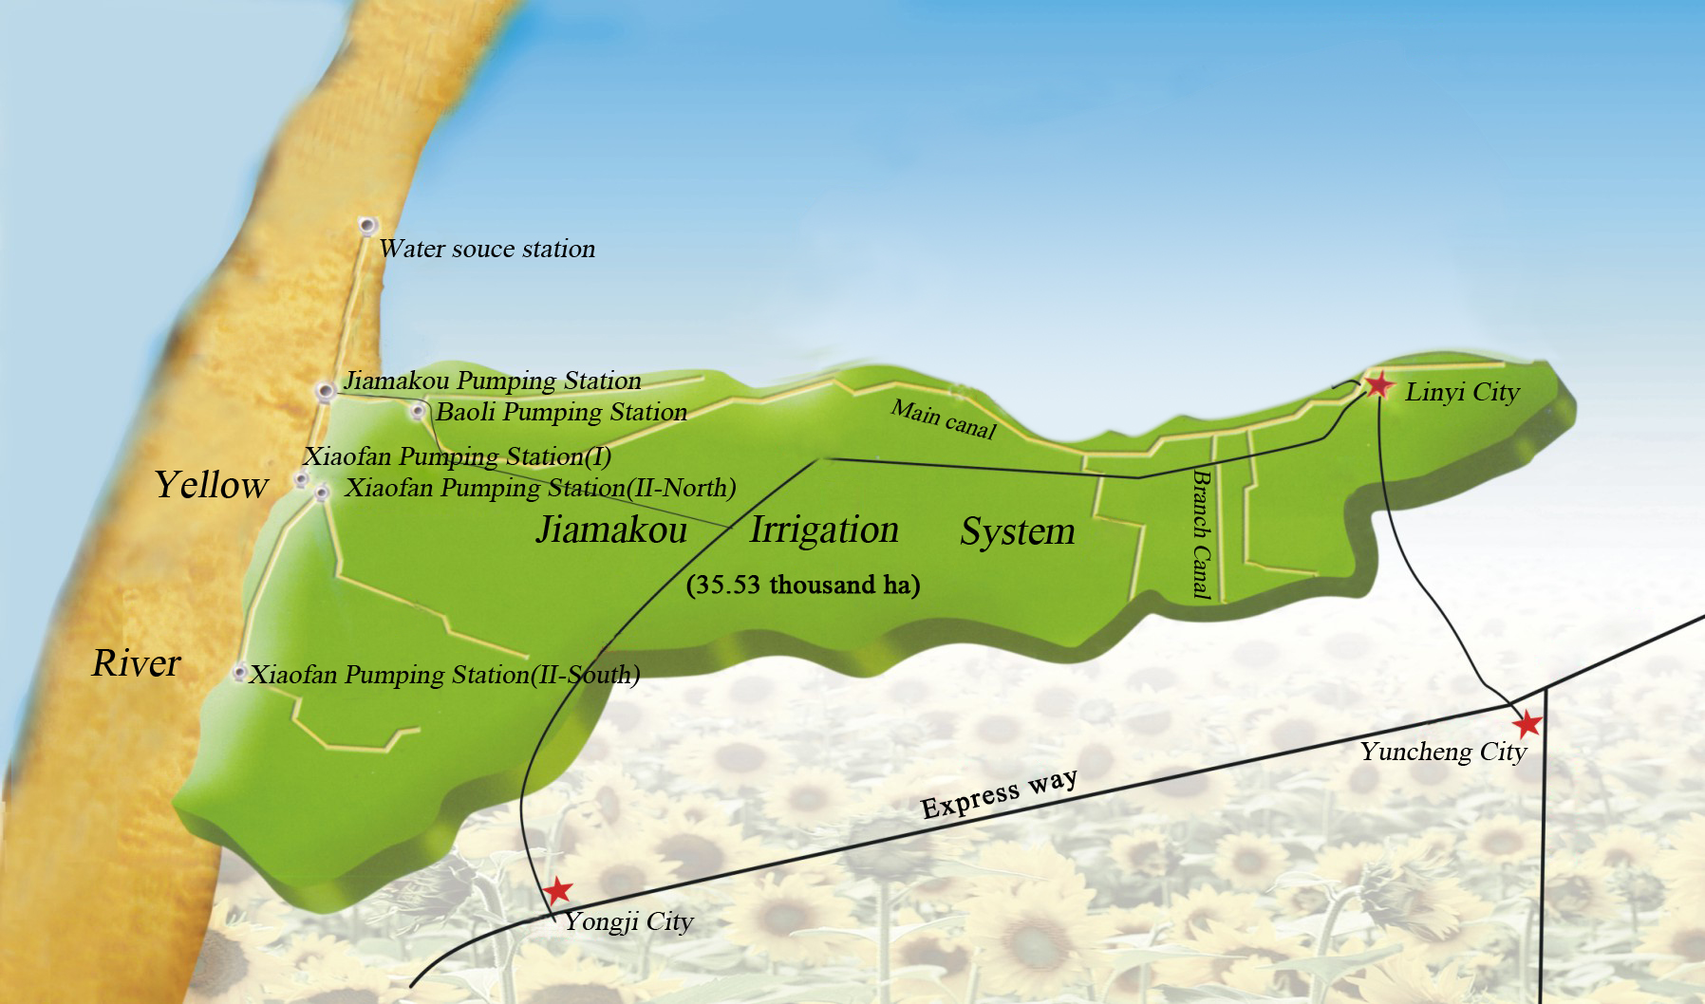
Fig. 1 The area served by Jiamakou Irrigation System
The Yuncheng City, as the agricultural production base of Shanxi Province has a total population of 5.02 million, of which 70% (3.51 million) is agricultural population, and a total land area of 14 thousand km². The total cultivated land area is 584.9 thousand ha and per farmer cultivated land area is only 0.14ha. Though with good natural conditions and great potentials of agricultural development, the city is critical shortage of water resources. Currently, the average water availability per capita in Yuncheng City is 281m³, the lowest in the whole Shanxi Province and about 12.6 percent of the national average (2229m³).
The JYRDP, commenced in July 1958 and put into operation in July 1960, is the first large-sized high-lift irrigation project in Yellow River basin. After a rehabilitation program of pumping station and irrigation canals in 1998, the project integrated water sources, water pumping and lifting, and irrigation canals into a holistic agricultural irrigation service scheme. The designed lifting capacity of water source project is 55m³/s and current actual capacity is 51m³/s. There are two primary pumping stations, i.e. Jiamakou pumping station with lift of 70m and Xiaofan pumping station with lift of 67m, in which, there are 27 pump sets, with a water lifting capacity of 23.2m³/s. The designed irrigation area is 33.53 thousand ha, benefiting 250,000 populations of nine towns in Linyi County and Yongji City. The area is a purely agricultural irrigated area, and cropping pattern has been adjusted since early 1990s, shifting from wheat, cotton and other cereal crops to fruit trees. By 2008, fruit trees (apple, grape, pear, peach, apricot, Chinese date, persimmon, etc.) has accounted for 80%, cotton 15%, and others 5%.

II UNDERSTANDING TO MODERNIZATION MANAGEMENT OF IRRIGATION SYSTEM

In the market economy system, with the industrial restructuring of irrigated area and the intensive agricultural operation, the water users ---- farmers had higher requirements for the water supply services to the irrigation systems. How to improve the services to meet farmers’ demand for water use and maximize irrigation water productivity has been the current challenge facing the Jiamakou.
Following the new thoughts of water management “promoting the transformation from traditional water management to modern and sustainable water management and ensure sustainable socioeconomic development” advocated by the Ministry of Water Resources, modernization management of irrigation scheme has become the only option for the irrigation systems and an essential component of water conservancy modernization.
Modernization management of irrigation system is a dynamic process in which the irrigation system carries out project construction and operation management in an all-round way by virtue of advanced technology and management approaches in the market economy system. According to the actual situation of Jiamakou irrigation system, define modernization management of irrigation system, that is, with the use of scientific management concepts and relying on advanced technologies and means, to reform management system, innovate operation mechanism, reduce operation cost, raise irrigation water use efficiency and water productivity, expand irrigation area, better serve the farmers and achieve the established management objectives.
III BASIC ELEMENTS OF MODERNIZATION MANAGEMENT OF IRRIGATION SYSTEM

Based on the understanding on modernization management of irrigation system, in order to realize the management objectives and irrigation modernization, firstly there should be scientific management thought and concept as guideline and management system and operational mechanism suitable for development of irrigation system as support, so that the healthy, sound and sustainable development of irrigation system. After years of practices, we think that modernization management of irrigation system should possess five basic elements (See Figure 2).

Fig. 2 The five basic elements of modernization management of irrigation system

1. Holding to the “soul” of management
JYRDP is in purely agricultural irrigated area where farmers are the service object and with high cost of water lifting, the existence and development of irrigation agriculture is the existence basis of irrigation system. So the mission of the project is “The water demand of farmers is our urgent target, save every cubic of water and every kilowatt-hour of electricity”, and the mission decides the trend of values. Fifty years’ history of Jiamakou project forms the core values of “Trust employees, strictly practice thrift, advocate civilization, pursue excellence, emphasize team-work, and give first priority to farmers’ interests”. Such values are key to project management and motivate JYRDP staff, and also enable staff to strive for excellent service, resources saving and environment-friendliness.
2. Specifying the “concept” of management
JYRDP is a quasi-public water conservancy management agency of institution property. In order to ensure the optimum operation of irrigation system, the Jiamakou put forward the macro management concept of “Construction depends on the state, while benefits relies on ourselves” and the overall orientation of management “Establish the thought to serve for agricultural production of irrigated area; take people as the foremost and center on economic benefit increase; proceed from reality with scientific decision and reinforcement of management with great efforts”. The irrigation system practiced separation of “administrative management” and “business activities”. The administration bureau is managed as an institution, pumping stations as “factory-like enterprise” and the irrigation main and branch canals as “commercial market”. Pumping stations, main canals, branch canals and tertiary canals, directly participated in water goods business, are treated as business entity and farm households are consumers of water. In practice, the management featured with “taking main part as analog legal unit, keeping separate accounts as enterprise, buying and selling water as on the market and providing standard service in open” is performed over water business entities.
3. Sticking to the “objective” of management
Agricultural irrigation is the sole economic pillar of the irrigated area, and the farmers’ interests have direct impacts on exerting the benefit of water project. Therefore, the common interest of farmer, the project and employee was identified for management objective. How to increase farmers’ income is the first element of management goal. How to make use of the investment, maintain and increase the value of state assets and ensure the continuous and optimum operation of irrigation system is the second element of management goal. How to keep the stabilization and vigor of the members is the third element of management goal as the staff is the principle part of the project. The three elements above are indivisible and indispensable, and consist of “increasing farmers’ income, sustaining the incremental value of the project and maintaining facilities in good working condition, and benefits of employees”, which are the management objectives of modernization management and usually called “Three-win” management goal (see Figure 3).
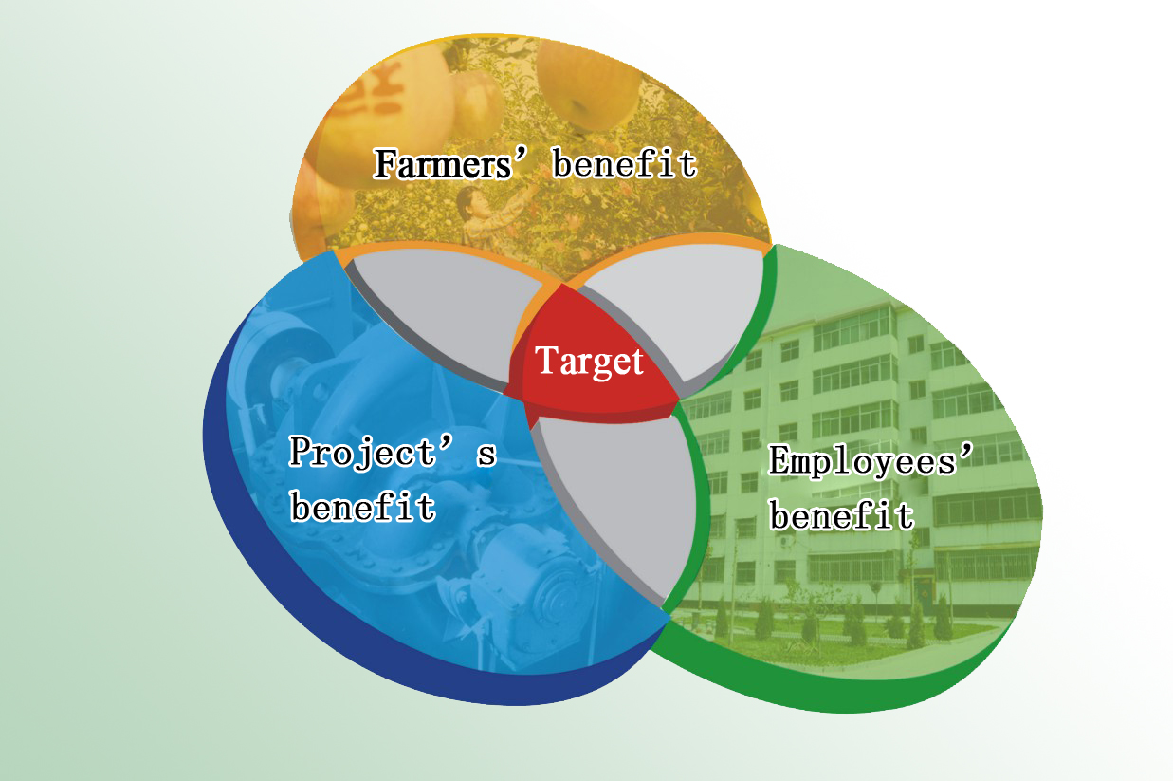
Fig. 3 The “Three-win” management goal

4. Establishing management system and operation mechanism
With the establishment of market economy, the management system and operation mechanism under planned economy period could not meet the requirements of the new order. In order to accelerate the establishment of the management system and operation mechanism suitable for the situation of socialistic market-directed economy, and achieve “Three-win” management goal, the system implements separation of “ administrative management” and “business activities”, establishing every pumping station and every irrigation canal into an analog legal unit with clear property rights, specific rights and responsibilities, scientific management, independent in management, self-sufficient in finance, and only if the mechanism introduces business operation mode, establishing the operational mechanism and modernized operation system with scientific management, normative operation and coordinated running, and actively developing electric business, chain business, and logistics and other modernized circulation modes.

5. Using advanced technologies
JYRDP serves for 250 thousand people, covering 9 towns of two counties (cities) and irrigated area of 33.3 thousand ha and undertakes the task of water supply of Yellow River to thousands of householders “in time, with sufficient volume, and in high efficiency”, so traditional management modes and methods can’t be adapted to the development requirements of the irrigation system. Only by means of advanced irrigation technologies, measurement technique and information technology, can we realize the objective of modernization management of irrigation system.

IV BENCHMARKING MANAGEMENT

In Jiamakou, the modernization management centered on the objective of “Three wins”, specified “five basic elements”, and established “nine management systems”, i.e. Organization Management, Human Resources Management, Management of Water Goods, Management of Water Business Entity, Project Construction and Maintenance Management System, Property Management, Management of Services for Farmers, Archive Management, and Management of Scientific Evaluation. Interpenetrating and independent to each other, these systems covered the service and business on construction and management of the whole irrigated area. The achievements are described hereunder.

1. Organization Management
The organization management system of modernization management is aimed at separating the administrative affairs and business activities, clear defining responsibilities and rights, giving full play to the work enthusiasm and subjective initiative of cadres and employees and bringing everyone into play.
1.1 The separation of “institution” and “enterprise”
With the transfer of planned economy to market economy, the service object of the irrigation system changes to each farm household from the collectivity, facilitating the transformation of the extensive pure public services to the market-oriented quasi-public operation. The importance is attached to not only social benefits, but the water saving and economic benefits. The original organization cannot fulfill the requirements of management transformation of the irrigation system. According to the principles of disaggregation of administrative affairs and business activities, the organizational framework of the irrigation system is divided into four major sections, i.e. administrative management agency, integrated affairs management agency, water business entity and logistics service agency, under the director responsibility system (See Figure 4).

Fig. 4 The organizational framework of Jiamakou Yellow River Diversion Project

The administrative management agency of the irrigation system includes divisions of finance, engineering technique, human resources, irrigation management and research, and offices of party committee, discipline inspection and supervision, public security and water administration, general management station for branch and tertiary canals, committee of the labor union, committee of the communist youth league, and women’s committee, executing the functions like macro-control of standard and institutional construction and carrying out institutional management.
The integrated affairs management agencies carry out institutional management and execute the function of administrative management and are representatives of the administration bureau, including Jiamakou office, Linjin irrigation center, Kaolao irrigation center and nine water management stations for branch and tertiary canals, which provide irrigation consultation and services for the farmers.
Pumping stations, main canals and branch canals in the irrigated area directly engaged in or participating in the operation of water goods are collectively referred to “water business entities”. Market-oriented supplier-buyer relationships exist between entities, and each entity keeps separate accounts and is an analog legal unit.
The irrigation experimental station, information center, communication station and departmental affairs station, and Baojie laundry center, Jiamakou building as well are logistic service agencies.
Every agency has a relationship of close cooperation and mutual restriction, and formed a sound operation mechanism of “Marco regulation of administrative agency, separate accounting and self-sufficient in finance of business entities and comprehensive services of logistic agency”.

1.2 Simulating Enterprise Operation Mode
Among the water business entities, pumping stations are water producers, main, branch and tertiary canals are water sales units and farm households are consumers of water (see Fig 5). This formed an irrigation water use market from the pumping stations to farmers. Each water business entity, acting as “legal person” and with the buyer-seller relationship built among them, has full decision-making power in the irrigated area. The administration bureau pays salary and expenses to water business entities according to the amount of water lifted and sold and the completion degree of the specified target. During the irrigation season, water supply system, water supply procedure and relevant accounts are to disclose to all farmers, and the farmers enjoy the legal rights and interests of irrigation water use. Due to such simulating the enterprise mode, we arouse considerable enthusiasm, decrease operational costs and improve irrigation water productivity.
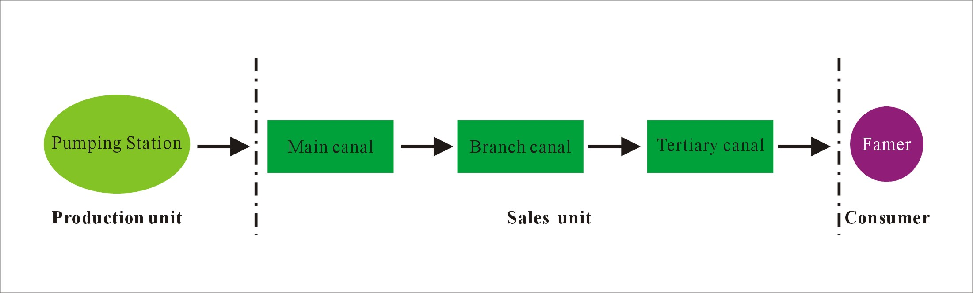
Fig. 5 Simulating Enterprise Operation Mode

2. Human Resources Management
The human resources management system of modernization management is intended to bring full play to the work enthusiasm and creativity of each employee, to reduce labor cost and to improve the overall efficiency of management. For the human resources management in Jiamakou irrigation system, the following five aspects have been identified.
2.1 Delimit organizational structure and positions strictly
(1) Delimit organizational structure and positions is a precondition of human resources management. Its purpose is to detail the work, to clear define responsibilities. To delimit organizational structure and positions is largely, in accordance with current national policies and laws and technical standards, to refine the principal body, set up positions according to affairs, fix responsibilities according to positions, and fix the number of employees according to the workload, in order to fulfill the requirements of system reform and mechanism innovation of the irrigation system. The total position of the whole Jiamakou Irrigation System is 713.

2.3 Scientific employment
The quality of employees and cadres has a direct effect on the management and development of human resources of the irrigation system as well as on the overall development of the water conservancy project. Therefore, with regard to the nurturing and engagement of middle-level cadres, the importance should be attached to the work described as below. First, each cadre should function and make more achievements; Second, laying stress on the moral quality and personal quality. A cadre appointed should be virtuous, intelligent and be capable of making achievements; Third, the establishment of virtuous incentive mechanism. The competitive employment and incentive mechanism are introduced, and the dynamic examination and evaluation are carried out. Fourth, a distribution mechanism is established based on achievement. The wage distribution and incentive system fitting to the characteristics of work and linking to achievements and actual contributions is established in order to fully inspire employees’ enthusiasm and creativity.

2.3 Improving employee’s executive force
In the modernization management practice, employee’s executive force is considered as treating the work strictly, making no excuse, keeping the own responsibility in mind at every moment, materializing the sense of responsibility and the spirit of devotion to the undertaking of the irrigation system, and dealing with trifles carefully and with details accurately. Execution is an important element linking objective to result, and determines whether the organization can achieve the anticipated objective. To solve the problem of executive force, in a word, is to let the correct person do correct things correctly, where “three corrects” are closely connected and integrated and their sequences cannot be broken.

2.4 Institutionalizing management behaviors
With the purpose of arousing employees’ correct understanding of “etiquette” (rules and systems), the irrigation system strengthens institutional construction. In recent years, the human resources section work out rules and regulations from different angles of management and amend them according to the changes of the irrigation system, and a series of management regulations has been introduced and improved, such as “The regulation of annual review and evaluation for all staffs”, “The rule for temporary employee”, “The rule for leave and resumption of leave”, “The regulation for absence without leave” and “The regulation for evaluation and employment of professional title”. Through institutional construction, the integrated area will abolish the old framework of people managing people, adopt the new mode of institutionalizing management behaviors, and realize management functionalization, institutionalization and standardization.

2.5 Intensifying employee education and training and building an incentive mechanism
Employee education and training is an important component of human resources management. New employees should accept pre-post education and training organized by the human resource section before taking on job in the irrigation system and professional technical training after going on duty. The objective of training is to let new employee have a comprehensive understanding of pumping station, irrigated area, and culture and operation concept of the irrigation system, and adapt themselves to work environment and get used to new working methods. At the same time, a diversified, independent and flexible distribution mechanism is built. In Jiamakou Irrigation System, the distribution system emphasizes contribution and performance, provides suitably preferential distribution to the personnel working in front-line positions and key technical positions, and amply rewards the individuals who make achievements in technical innovation and outstanding contribution. All these measures fully inspire employees’ enthusiasm and improve the cohesion and fighting effectiveness of each department.

4. Management of Water Goods
The management system of water goods is established in the modernization management to decrease water consumption and irrigation cost and improve water productivity. The water goods is managed with reference of “three-circulation management theory” of modern enterprises, namely, management of commodity (water) circulation, capital (water fee) circulation and information (water information) circulation (see Figure 6).

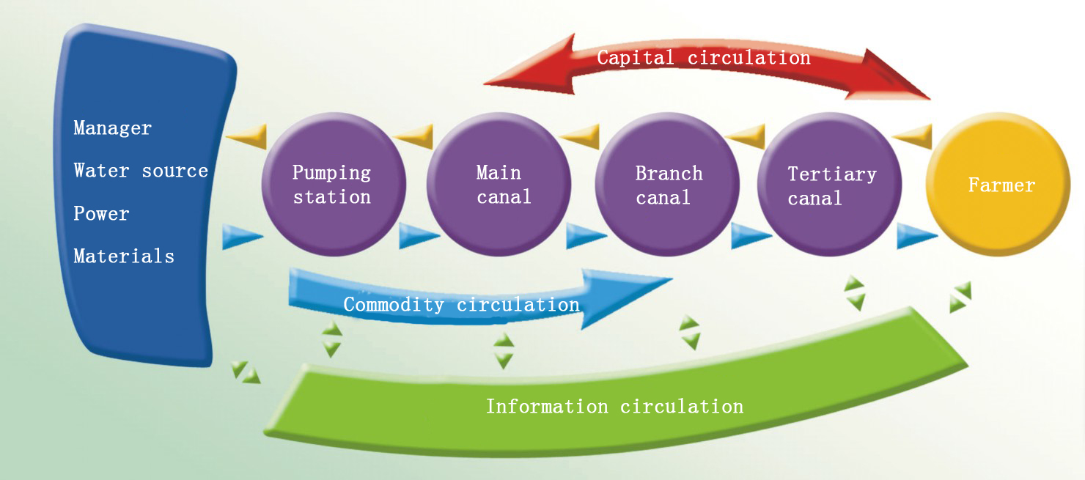
Fig. 6 “Three-circulation” management theory of the irrigation system

  - Management on water circulation (commodity circulation)
The management on water quantity is to plan, organize, direct, coordinate, control and supervise the irrigation water supply process. Its purpose is to decrease the water supply cost and improve the water utilization efficiency and economic benefits.
(1) Drawing up the schedule of irrigation water diversion. Before the irrigation season, the irrigation management section will complete the detailed water diversion program according to rainfall forecasts, cropping patterns, irrigated areas and irrigation quota, with reference of the actual amounts of water diverted in the last three years, and meanwhile, breaks down the water diversion task to each water business entity.
(2) Supplying water according to farmers’ demand. During the irrigation season, the management station of main canals will collect information on water demand at specified time (20:00) and then reports it to the water-controlling center, which will determine the number of working pump sets. Pumping stations and main canals carry out water selling and buying through scientific measurement.
(3) Scientific operation and rational distribution. The water operators from main canals provide sufficient water to each branch and tertiary canal safely and stably according to individual water delivering capacity.
(4) Flexible, stable and sufficient water supply. After receiving water from the next upper canal, the heads of tertiary canals is responsible for the stable, sufficient and timely supply of water to the farmers. Parshall flumes are used between main and branch canals and cut-throat flumes are used between branch and tertiary canals for water volume measurement. Accurate measuring facilities are equipped for each canal in the irrigated area.
(5) Information feedback. When the irrigation season ends, the irrigation management section collects and analyzes the information concerning the water diversion and distribution of each water business entity and water use of each farm household and keeps a “water use credit” file for each farm household.

4.2 Management on water fee (capital circulation)
According to national financial regulations, we have rules for fund collection and expenditure, which include the collection of water fees and expenditures.
(1) Water fee collection management
- The head of each tertiary canal buys water tickets from the local township water management station before irrigation application according to the amount of water demanded at individual tertiary canal with his own money and the administration bureau of Jiamakou pays him 1% of the prepaid amount as risk reward.
- With the water ticket, the head of each tertiary canal obtains the water at the canal turnout and is responsible for the water distribution to every household. Each time after use of water, the household signs on the “Farm Household Water Use Record Form by Jiamakou Yellow River Diversion Project” (simply referred to as “Record Form”) to confirm the water fee to be paid by the household.
- After irrigation application, the head of each tertiary canal goes to the township water management station with “Record Form” signed by farmers to print the receipt of water fee of each household and then collects water fees from the farmers according to the receipts (supermarket-like management on water use).
- After the collection of water charges, the head of each tertiary canal settles the accounts with the township water management station and then returns the overcharge and demands payment of the shortage.
- Each township ticket sales point hands over the collected water fees to the administration bureau every ten days. The water fees shall be managed according to relative laws and regulations to avoid fund interception and appropriation.

(2) Fund expenditure management

Fund expenditure management is twofold: expenditure by the managing units and administration management. For the former, the expenditure amount is settled according to the actual achievement in the light of the contracted quota. For the latter, expenditure follows strict rules for planning management and approval procedures. The procedures are:
- Financial expenditure is managed according to plans with reference to income.
- According to the income from water fees and the principle of production first, the financial section makes all the expenditure plans, then reports to supervisors and the head of the administration bureau.
- Expenditure is made according to the approved plans.
- After expenditure, the undertakers submit the expense to the head of the unit for approval, supervisors and the head of the administration bureau.

4.3 Management on water information (information circulation)
Information circulation facilitates the management on commodity circulation (water) and capital circulation (capital) and feeds back and processes the data produced in the “commodity circulation” and “capital circulation”. To manage the water information well, advanced information technology must be adopted and a perfect “hydro-informatics system” must be established. This system includes nine management systems, i.e. main communication network system, farm household management, pumping station automatic monitoring, irrigation management, decision-making system for irrigation management, water fee collection, financial management, project management and office automation system. Each system is independent and relates with others. And their functions are respectively:
(1) Main communication network system. The system is the framework of the JYRDP information system. The internal communication network is established with reference to the geographic location and topography of each communication point in the irrigated area, while adopting wireless microwave and optical fiber, to achieve the safe data transmission, voice transmission and video monitoring.
(2) Farm household management system. The system stores the basic information of each water consumer in the irrigated area, planting area, cropping pattern and water use information, creates files for farmers and water user accounts, answers water fee inquiries via telephone and PCs, and print water fee receipts for water fee collection. The system greatly improves the openness of water management process and helps the farmers to monitor the irrigation management.
(3) Pumping station automatic monitoring system: The main functions of the system are as follows: to automatically retrieve, display and transmit relevant parameters of pump sets, main transformers and observation points of Jiamakou pumping station; to control the operation and protection of the pump sets of Jiamakou pumping station with computer; to dynamically display the running parameters of the principal machine, auxiliary machines and various equipment, and to collect the main parameters, such as water level of suction sumps and outlet sumps, discharge of pump sets, and sediment content of forebay. It basically achieves the remote adjustment, remote measurement and remote control of Jiamakou pumping station.
(4) Irrigation management system. The system is the core of the irrigated area information system. The system includes five modules (pumping station management, main canal management, branch and tertiary canal management, measuring section management, and integrated affairs management). It involves all the links in the whole water flow process and water distribution service in the irrigated area, from water lifting at pumping station, distribution at the main canal, delivery and distribution at branch canal to the water business management at tertiary canal (farm household) and all the data are entered into the irrigation management system to provide basis for the scientific design of annual irrigation task and quarterly irrigation plan.
(5) Decision-making system for irrigation management. The system determines the water demands of different crops and plots over alternate periods, compares the water consumption of each water user unit in different periods and adjusts the crop water requirement in time to finalize the best irrigation program.
(6) Water fee collection system. The system mainly serves the farmers to print water fee receipt and provide relevant reports. At the same time, the administration bureau of Jiamakou gets to know the status of water fee collection in real time through the system.
(7) Financial management system. The system achieves computerized accounting to gradually meet the financial management requirements of “consistent, convenient, quick and standard” and improve the working efficiency. At present, the four management modules of accounts and statements management, fixed assets management, salary management and report forms management have been applied.
(8) Project management system. To draw and revise the map of the irrigation area; to locate and describe the main infrastructure; to keep electronic files of schematics; to oversee network management of materials submitted to the project.
(9) Office automation system. The system basically achieves the on-line delivery, receiving and passing round of files and statements, examination and approval, disclosure of public information, and communication among the staff of different levels in the administration bureau of Jiamakou. And it has the functions of personal email box and personal affairs and archives management.
The above data are entered at user ends and then transmitted to the database of the information center of the administration bureau and fed back to user ends according to different limits of authority after analyzing and processing to achieve information resource sharing in the administration bureau.

4. Management of Water Business Entity
The separation of administrative affairs and business activities is implemented in the modernization management of Jiamakou. In the practical operation, pumping stations, main canals and branch canals, directly engaging in and participating in the commercial operation of water goods, are collectively called as “water business entity” and treated and operated as “an analog legal unit” in the irrigated area. The establishment of management system of water business entity is to break the traditional distribution mode of absolute equalitarianism, motivate the staff of each pumping station and canal, minimize the operation cost and increase the overall benefits of the irrigation system.
Water business entities, as producer and operator of water goods, are relatively independent and managed as analog legal units in the irrigated area, which has the status of a legal person and decision-making power in the irrigated area, such as it may independently determine its internal organization; employ group leader, team leader, chief dispatcher and section leader for canal management section; rearrange the posts of the staff and bring forward the suggestions on recruitment or dismiss; design salary distribution mode suitable for the entity.
Each water business entity had a contract with the Administration Bureau of Jiamakou, which specified the amount of water lifted and sold and other tasks, and keeps separate accounts, with payments linking with performance and manages their business on their own and assumes sole responsibility for profits and losses. The expenses and salary, bonus and subsidy of staff calculated according to the amount of water pumped and sold are paid once an irrigation season.
All in all, the administration bureau pays salary and expenses to water business entities according to the contract and the completion degree of the specified target, while the water business entities fully make use of project facilities, man power and technical conditions, enlarge the range of service, gradually improve service ability and quality, develop economic growth point and enhance the self-financing level and income level.

5. Project Construction and Maintenance Management System
The purpose of this system is to improve infrastructure capacity and to ensure the healthy and sustainable development of the irrigation system. This system has the following objectives:
(1) Good project design: For those projects in need of extension, reconstruction and water saving rehabilitation, the engineering technical section performs a site survey and detailed reconnaissance together with the department of water conservancy engineering design, and then performs the engineering design of the projects according to the water conservancy engineering design standard and requirements and submit relevant plans to the superior administrative department for approval.
(2) Public tender invitation and bidding: For approved projects, the procedure of public tender invitation and bidding must be went through strictly according to Rules on the Management of Tender Invitation and Bidding of Water Conservancy Projects to select the best construction enterprise with good reputation and powerful strength under the open, fair and justice conditions.
(3) Project construction management: The basic construction procedure of water conservancy project and the requirements of “project legal person responsibility system, public tender invitation and bidding system and project supervision system and contract management system” must be strictly followed in the project construction management. The construction enterprises with excellent qualifications, powerful strength and rich construction experience are selected by the principle of “openness, fairness and justice” to ensure project construction progress and construction quality. The supervision unit supervises the project quality according to the requirements of “three controls and one management”.
(4) Project acceptance: In intermediate acceptances, “self-inspection, mutual inspection and hand-over inspection” are performed carefully. After project completion, relevant departments will conduct a general inspection on the design, construction and quality. After the final acceptance, the project is put into operation.
(5) Professional routine maintenance: After commencing operation, the project will be inspected every season to ensure proper maintenance is in place according to the principle that “the user is the maintainer”. The responsible person of each unit is the primary responsible person of project maintenance to ensure a neat environment, sound facility and flexible operation.

6．Property Management
The property management includes treasure management and goods and material management. In the modernization management of the irrigation system, the property management system is established to make ends meet, achieve standard and transparent property management, and to spend every cent on the item needing it most. The details of property management are as follows.
1. Expenditure management procedure for project operation
The management of expenditures for project operation includes the expenses of water operation entities and administration expenses. The expenses of water operation entities are paid according to the completion degree of the target specified in the contract of each operation entity. The procedure: examination of the financial section – examination of director responsible for this – approval of the director of the administration bureau – settling accounting in the settlement center of Jiamakou water business entities. The plan-oriented control and approval procedure are strictly performed to manage administration expenses. The procedure: the approval procedure of responsible person of the unit – examination of the financial section – leader responsible for this – the director of the bureau.
2. Financial settlement procedure for project construction
- The construction enterprises submit payment applications;
- Examination of the construction quantities by the section of engineering technology;
- Examination of the construction quality by the supervision section;
- The financial section submit settlement application;
- Leader responsible for project construction
- The director of the bureau
- Render an account and fund appropriation at the city accounting center through the financial section.
3. Fund appropriation procedure for project construction
- The section of engineering technology makes construction settlement;
- Examination of the planning and finance department, city water affair bureau;
- Examination and approval of the city finance bureau;
- Payment transferred to the Jiamakou account at the city accounting center by the city finance bureau.
4. Goods and material purchase procedure
- Submitting of material plan by the units;
- Examination of the financial section;
- Examination of director responsible for this and approval of the director of the administration bureau;
- Purchase of the materials by purchase;
- Registration of goods and materials entered the warehouse.
5. Goods and materials utilization procedure
- Filling up the material receive request by the unit;
- Signature by the director of the unit;
- Recording by the storekeeper;
- Receiving the material.

7. Management of Services for Farmers
As the major consumers of irrigation water, the farmers enjoy the legal rights and interests. The objectives for the modernization management by building up the management system serving for farmers are to establish and improve the water users associations (WUAs), implement the “Sunshine Project”, raise the service level, supply the water “timely”, “fairly” and “reliably” to farmers and increase farmers’ income.

The management of services for farmers is mainly reflected in three aspects:
- To help farmers establish WUAs so as to make up for the vacancy in the “management” at the tertiary level. Standardize the tertiary canal management and ensure the full optimization of the project benefits.
- To guide farmers in scientific irrigation and conservation of water. Through weather forecasting and soil moisture content measurement, the irrigation scheduling for different crops are explored to guide farmers to irrigate appropriately in order to maximize the irrigation benefits.
- Implement the “Sunshine Project” and lighten farmers’ burden. The essential point is “making water affairs public”. Through enhancement of water measurement, the “three publicities and one to-field”and “one-ticket-charging”，and water fee inquiry system are implemented to effectively restrain price hikes and reinforce the transparency of water use.

The township water management stations are the irrigation service stations for farmers, helping them to do well in the following matters:
- Establishing WUAs –– “tertiary canal management commission” in the irrigated area (abbreviated as “TCMC”). The irrigated area takes the tertiary canals as the units for setting up “TCMC” and elects a director for each TCMC, who is the legal representative of a TCMC and responsible for farmers’ interests. The director is responsible for employing irrigation managers for the tertiary canal who are responsible for the maintenance of the canal and farmers’ irrigation.
- Delivering sufficient water to farmers. Before irrigation, the head of the tertiary canal contacts the next higher canal in the chain to determine the water release time and flow rate, and distribute water to each farmer’s field.
- Supplying timely and sufficient water and carrying out an open water commodity system. During distributing water to fields, the head of the tertiary canal is responsible for implementing the “three publicities and one to-field”, ensuring the publicity and transparency.
- Establishing water users’ account for farmers and realizing the water use management in supermarket style. After every irrigation application, the head of the tertiary canal submits the filled forms to the township water management stations where the operators enter all data into computers and print water use receipts.
- Disseminating water use information via a bulletin. After delivering the water fee to the township water management stations, the head of the tertiary canal will disseminate household water use forms via bulletins for public oversight.
- Making the water use more transparent through public inquiry. After every irrigation application, water users can inquire the water consumption and water fee through the “water charge inquiry system by phone”. Meanwhile, they can also inquire more detailed information through the “touch-screen water fee inquiry system” in the township water management station.
- Enforcing the law to ensure farmers’ interests by establishing “public security and water administration section” and an “irrigation inspection team” with offense reporting hotline. During the irrigation season, the farmers can consult and lodge complaints for 24 hours a day. Thus water abuse cases can be penalized, staff behavior is regulated and farmers’ interests are protected.

8. Archive Management
The archives of the irrigation system indicate the total of information, which is valuable for reference and preserved together, formed by administrative offices and water business entities in various activities. The archive management adopts the principle of “unified leadership and sectional management”, that is to say, the administration bureau establishes the unified archive management system and the archives of the whole bureau apply the unified standard. All sections set up archive management units. The archive office of the administration bureau carries out the comprehensive management to all archives in the irrigation system.
With wide application of computer technology in various fields of the management of the irrigated area, the Jiamakou Irrigation System achieved information resource sharing, water use receipt print, water fee inquiry and water resource regulation. So the electronic archives become an important component of archive management. The electronic archives of the irrigation system are formed by the data and information recorded by number codes, which is formed through computer and web, recognized, processed, transmitted and stored on media by computer.
To strengthen the electronic archives management, the following matters should be done well:
- Every section and unit appoints special person responsible for the electronic archives arrangement. The collection, settlement and maintenance of electronic archives of whole administration bureau are managed by the information center.
- The storage media with high universality, large capacity, long service life and rapid data access are used for building up the electronic archives. The carrier and contents of electronic archives can carry through readability test and maintenance. The methods like backup and transcription can be adopted to guarantee the reliability of data storage and output of electronic archives.
- Converting the formats of electronic archive at a proper time can always keep the compatibility with new technology, so as to ensure the readability of electronic data and provide a basis for the irrigation system management.
- Keeping the electronic archives in the waterproof, antimagnetic and anti static cabinets with proper temperature and moisture to extend their utilization life.
- Build the institution of electronic archives secrecy and ensure the safety use of electronic achieves.

9. Management of Scientific Evaluation
The purpose for establishing the scientific evaluation system is to conduct all-around evaluation on various works in project construction and irrigation system management, promptly identify and solve problems in operation and management, advance step by step and continuously improve the modernized management level.
On principle of “diversified review and assessment, quantification of each evaluation index, modernization of operating devices and standardization of the entire operation”, a multi-angle, multilayer and all-around overall evaluation is conducted to water business entities. The specific evaluation indexes are defined by a gradual increase based on the average standard of the previous three years.
9.1 The review and assessment methods are:
- The reliability of water supply, the quota of each cubic meter of water and the coefficient of losses of every thousand tonnes per kilometer are calculated each season for pumping stations. Those units that cannot meet the standard will be fined by 15 percent of the overconsuming component and those that fall beneath the standard will be rewarded by 65 percent of the saving component.
- A rating system assesses facility maintenance of main and branch canals. According to project management and maintenance standards and evaluation criteria, we conduct a public appraisal of each water business unit with a total rating for each item of 5. The salary of maintenance staff is deducted by 5 percent if the rating is below 3 for one item, 20 percent if the ratings of three items are below 3 and 50 percent if the three items continue to remain below 3. It has been suggested that the tertiary canal management committee should dismiss the head of the tertiary canal if ratings are consistently low.
- At the end of the year, administration staff are reviewed and assessed.
- Comprehensive assessment indices will be applied to total annual social production — outputs and inputs — and an objective appraisal will then be made.

9.2 Some major evaluation indices include:
(1) Evaluation indices for pumping stations:
- The amount of water lifting: Evaluate according to the water supply quota specified by the administration bureau.
- Flexibility of water supply: Timely adjust the water flow rate and supply water according to the demand.
- Sufficiency of water supply: Meet the water need of main canals and supply water adequately.
- Reliability of water supply: Make the water supply is in time, stable and adequate.
- Cost of water per cubic meter: Evaluate the indexes like power consumption, power charge and maintenance cost for per cubic meter of water, exceeding “punished” and saving “rewarded”.
(2) Evaluation indices for canals
- The amount of water diverted to canals: Evaluate according to the water volume specified by the administration bureau.
- Water conveyance efficiency: Mainly evaluate the coefficient of water losses of every thousand tonnes per kilometer.
- The flexibility, reliability and equity of water supply to canals at the next level.
- Canal maintenance level
- The flexibility and reliability of infrastructure (regulation gates, diversion gates and flumes/weirs).
- Operation staff’s qualification.
- Internal management regulations.
- The availability of roads along canals.
(3) Review and evaluation indices for administration unit
- Work objective: Whether the job tasks deployed by the administration bureau are finished; the implementation of post responsibility system.
- Standardization construction: Mainly evaluate the articles of rules and regulations, various documents, account books, archive management level and staff’s calligraphy and so on.
- Work load: Summarize the quantitative records of individual workload and evaluate the workload of different posts (Quantitative Record Form of Staff’s Workload).
- Policy implementation and participation in project activities: Whether he/she actively participates in various group activities, follow and implement rules and regulations, as well as important decisions of the administration bureau.
- Training and education for staff: Evaluate according to the number of trainings organized each year, the number of attendees, along with the results of staff’s overall evaluation.
- Comprehensive annual review and evaluation: At the end of the year, cadres and staffs are organized to carry out the job satisfaction evaluation.
(4) Financial analysis indices
- Water supply cost
- Cost structure
- Operation cost of water business entity
- Operation cost of administrative institution
- Comparison analysis of production cost and administration cost
- Comparison analysis of salary and bonus
- Infrastructure maintenance cost
- Water fee collection rate
- Operation cost and water price official approval
- Financial benefits per unit of water
- Operation capability of human resources
- Conclusion of financial analysis
(5) Comprehensive evaluation indexes
- Annual net income and labor force income of farmers
- Productive value per unit area
- Irrigation water productivity: indicates the agricultural productive value increased in the irrigated area by lifting per cubic meter of water.
- Water use quota
- Irrigation cost: indicates the irrigation expenditure per unit area in a year.
- Unit power benefit: indicates the average benefit for 1kw of installed power.
- Irrigation water fee productivity: refers to the economic benefits produced by one CNY of water fee in the irrigated area.
- Annual irrigation water use efficiency
- Irrigation guarantee rate
- Employee income level

V INITIAL MODERNIZATION ACHIEVEMENTS

With gradual improvement and practice in the nine management systems, infrastructure capacity has been strengthened and service levels have improved in recent years — thus making an important contribution to local agricultural development, enhancing farmers’ income and nurturing the rural environment.
1 Increasing farmers’ income
With improved reliability of water resources and capacity of the pumping stations, the farmers receive punctual water supply. Data from 2007 showed that the annual average income of each farmer in irrigated areas reached 7,498 CNY, about 2.2 times that of other Yuncheng farmers.
2 Enhancing infrastructure capacity
After abstracting experiences and lessons learned from the Yellow River water diversion, we have solved water diversion problems by establishing the Wuwang floating pumping station. The expansion of Jiamakou and Xiaofan pumping stations has been finished and two new pump sets have been added, thus water-lifting capacity has increased from 9.5m³/s in 1998 to 23.2m³/s today. The actual irrigated area has increased from 12,333ha to 21,000ha. The water use coefficient at the main and branch canals has increased from 0.70 to 0.82. The collection rate of water fees reached 100 percent since the year of 1998 and income increased from 10.24 million CNY in 1997 to 22.76 million CNY in 2007. Fixed project assets have increased from the original 40.94 million CNY to 240 million CNY today.

3 Relatively stable staff
Through the increase in benefits yielded by the irrigated area, the annual income of each staff member increased from 3,300CNY in 1998 to 24,059CNY in 2008. Since 1998, we have recruited 57 college and university graduates. Out of 599 staff, there are seven senior engineers, 20 engineers, 45 assistant engineers, 228 technicians and 184 workers. With improvements in working condition and income, the administration bureau has become a solid unit, admired by many people.
4 Social benefits
Statistical data reveal that between 1960 and 2008 the gross agricultural production value of Linyi irrigated area reached 7.85 billion CNY, of which net water resource profits amounted to 3.14 billion CNY. In 2007, the gross value of Linyi irrigated area was 7.1 billion CNY with added value of 15.45 CNY per cubic metre of water. In May 2006, FAO conducted a five-day assessment of the irrigated area and made the following appraisal: “The overall irrigation benefits, water use efficiency and irrigation water productivity are all higher compared with other irrigated areas with the same conditions and lead the way in China and the Asia–Pacific region”.

VI MAJOR PROBLEMS

- Substandard management for tertiary canals: Although WUAs have been established, unbalanced development and lack of technical and policy support have resulted in weaker management.
- Water price reform is not complete: Because of the relatively low state of the economy, the existing water price is below the cost. During wet years, there are insufficient funds for maintenance and staff salaries so government subsidies are needed.
- Insufficient investment for tertiary canals: Less than 40 percent of canals are lined, so leakage losses and higher irrigation water cost remain major problems for irrigation in some areas. The improvement of tertiary canals can hardly be expected to depend solely on farmers’ investment. Investment by the government is needed.

VII CONCLUSIONS

Confronted by the demands incurred by a rapidly developing society, we acknowledge the need for responsible water conservancy to construct the new socialist countryside and the resource-saving, environment-friendly and harmonious society. On the path to further irrigation modernization, we will change water use concept, innovate development mode, expand irrigated area and improve water productivity by adhering to the requirement of scientific development view and the new thought of sustainable water management.
The future work should be introducing management measures and information technology both inside and outside China, which more scientific, more advanced and more suitable to Jiamakou Irrigation System. Consequently we will be able to accelerate the development and have better benefits of the JYRDP and achieve sustainable development targets. In the next five years, we will try to expand the upgraded irrigation area by 13,300ha (which makes the actual irrigated area meet the designed area), enhance water conveyance efficiency at main and branch canals by 83 percent, tertiary canal conveyance efficiency by 95 percent, irrigation efficiency by 70 percent and maintain relatively high irrigation water productivity for the betterment of society in general.

Three controls and one management mean investment control, quality control and progress control and contract management.
“Three publicities and one to-field”: Make public the water flow, water price, supply and stop time. Fill in the water-to-field form in the fields and farmers sign and stamp after confirmation (in duplicate).
After determining the various charge standards, the “unified water supply ticket” is used in the Jiamakou irrigation system, for receiving all water fee, tertiary canal management fee and tertiary canal construction charge, so it is called “one-ticket-charging”.

